**MH REPORT SYSTEM**

**User Manual**

**Revision 2.0**

**2018/06/08**

**Table of Contents**

1. **Installation Guide**
2. **Getting Started**
   1. **Change Settings**
   2. **FETP Team List**
3. **Main Menu**
   1. **MH Data Report**
   2. **Change Settings**
      1. **Generate Settings**
      2. **Change Settings**
   3. **Draw Graph**
4. **Sample Reports and Overview**
   1. **MH Report**
   2. **ERAJ Graph**
5. **Installation Guide**
6. Open the folder to where the MH Report System Installer is located and click ***setup.exe.***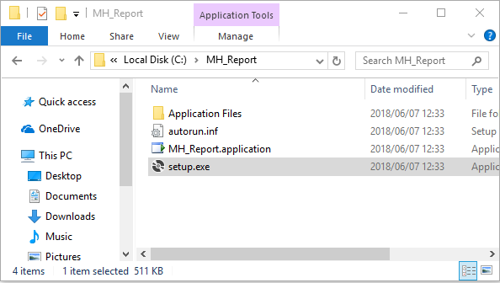
7. Wait for the system to complete verification.

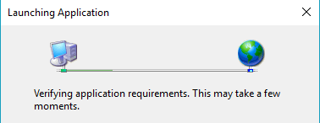

1. Click ***Install*** when prompted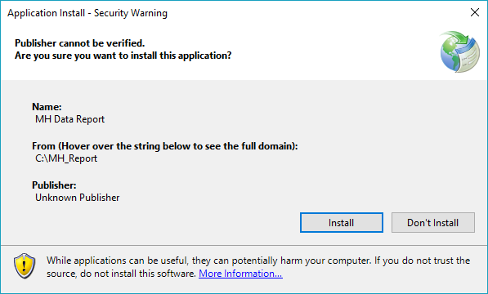
2. **Getting Started**
   1. **Change Settings**
3. On initial access, a warning message will pop up to request for settings configuration. Click the OK button.

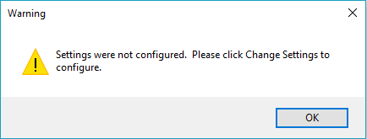

1. On the Main Menu, click ***Change Settings***. The MH Data Report button will be enabled once the settings are successfully configured.

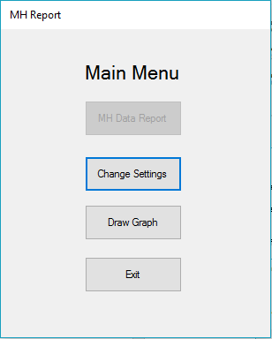

1. Click ***Generate Settings*** on the Settings Menu.

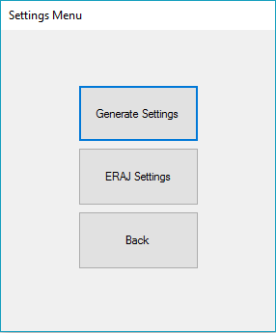

1. On the Change Settings window, click the ***Change...*** button to select the path for the Source Folder and Output Folder.

**Note:** The *Source Folder* is the location of the timesheets. The *Output Folder* is the location where the summary of timesheets will be saved.

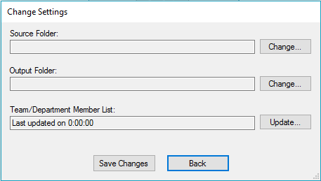

1. Select the location and click ***OK***

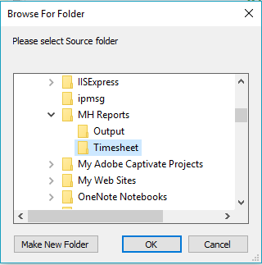

1. The selected location will be displayed in the textbox.

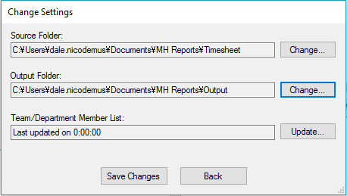

The Team/Department Member List displays the date when the FETP Team List was last updated. Initially, this will display*“Last updated on 0:00:00”*. (An excel file for the list of FETP Team is provided). Click the ***Update…*** button.

**Note:** For instructions on how to create the FETP Team file, please see **2.2 FETP Team List** on how to create the file.

1. Select the path where the FETP Team list is located and click ***Open***.

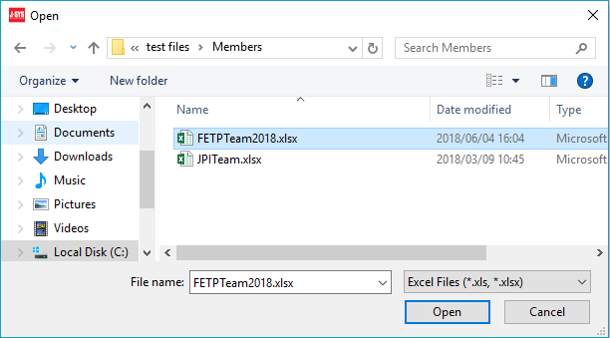

1. The location will be displayed in the textbox. Click ***Save Changes*** to save the system settings.

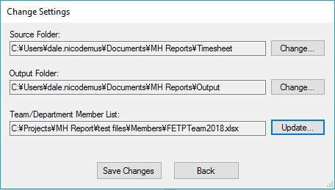

A popup message will show when settings were saved successfully.

Click ***OK***

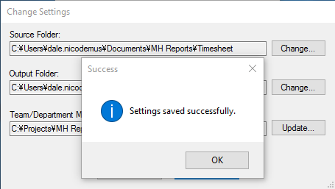

1. Back in the Settings Menu, click ***ERAJ Settings.***

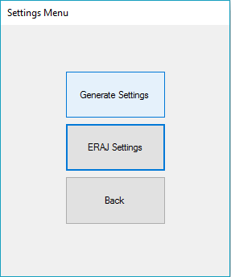

1. The ***Upload New Template*** window will show. Click ***Browse…*** and select the path for the blank ERAJ template. Click ***Open***.

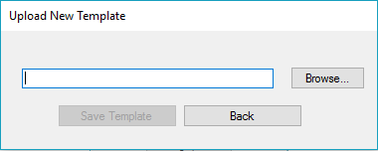

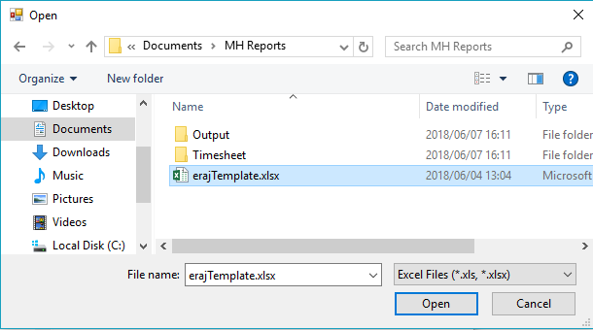

1. The template path will be displayed in the textbox. Click ***Save Template***.

This template will be used for the **initial** reports generation.

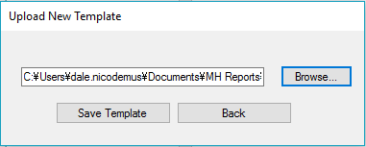

1. A message will show when successful. Click ***OK***

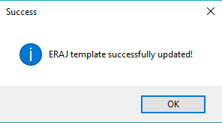

1. Then click ***Back***
   1. **FETP Team List**

The FETP Team List file contains the list of department/team names and each respective member.Below are the instructions on how to create the file.

**Note:** Always use the leftmost sheet of the excel file and not leave any blank rows, columns, or cells in between data.

1. List the team names horizontally from left to right starting at Row 1 and Column A. Place an “**end**” after the last item on the team names.
2. 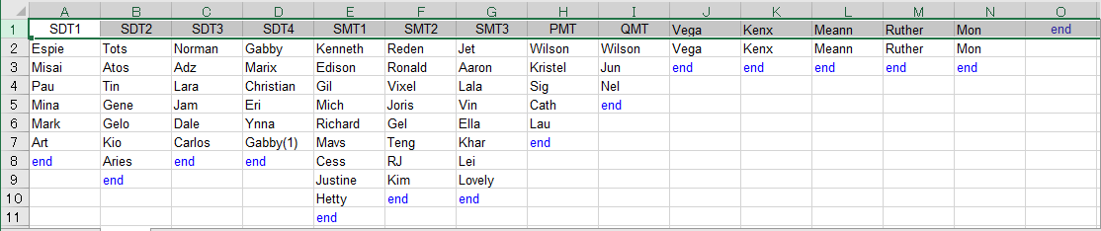List the members’ names per team vertically from top to bottom starting at Row 2 as shown below. Place an “**end**” after the last name on the list.

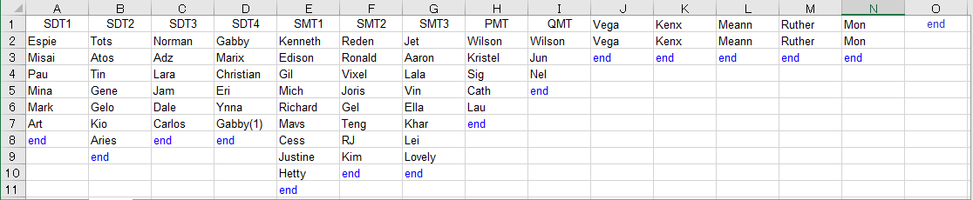

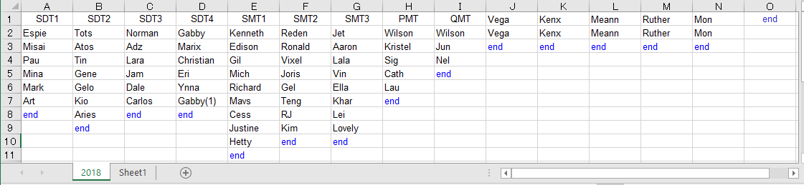 **Note:** Use the first and rightmost sheet to create the file.

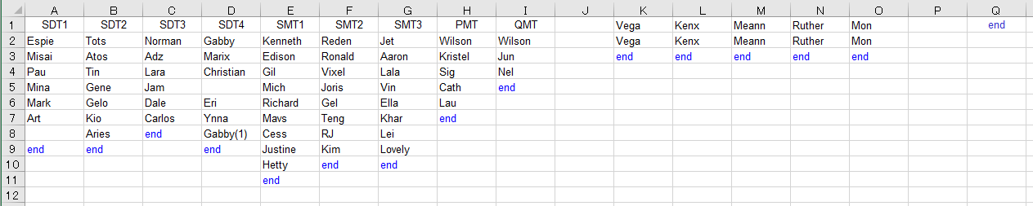**Note:** Avoid leaving spaces in between items.

1. **Main Menu**
   1. **MH Data Report**
2. Click the ***MH Data Report*** button to generate the summary of timesheets.

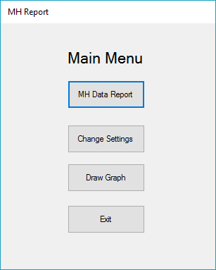

1. Select the ***year*** from the dropdown box.

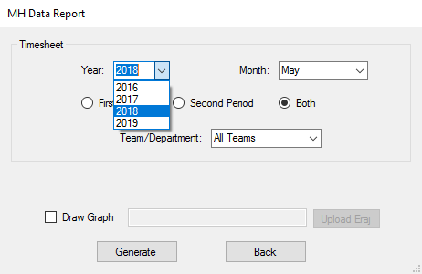

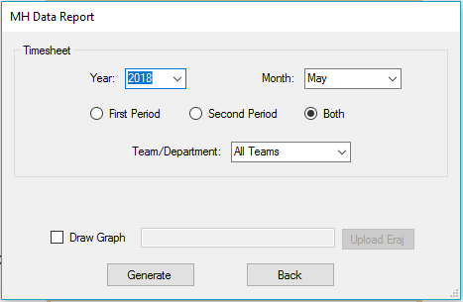

1. Select the ***month*** from the dropdown box.

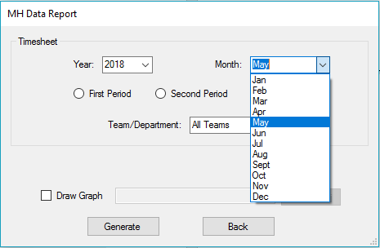

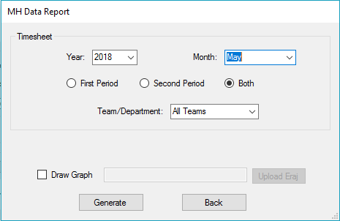

1. Choose the ***timesheet period***.

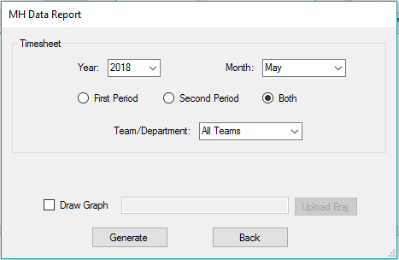

1. Select the team/department from the dropdown list.

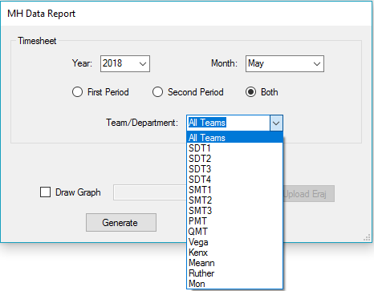

1. 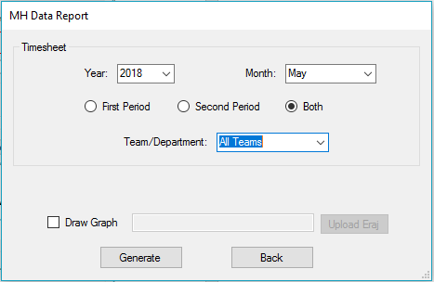**Optional:** Click on the ***Draw Graph*** checkbox to generate an ERAJ Graph.

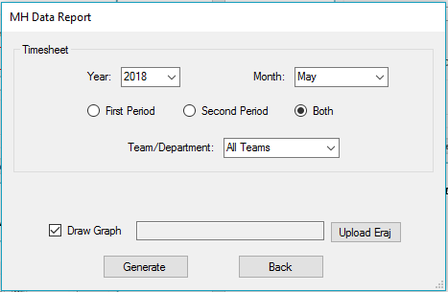

1. Click on the ***Upload Eraj*** button to use the previous ERAJ data file as template.



**Note:** Data from the previous months will be retained, and data from the selected month will be added. If no file is uploaded, the system will use the blank template that was set in the ***ERAJ Settings*** during the ***Getting Started*** step. Using the blank template will generate only one month’s graph.

1. Select the file to use and click ***OK***.

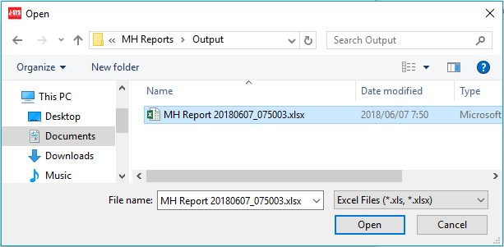

1. Click ***Generate*** to start processing.

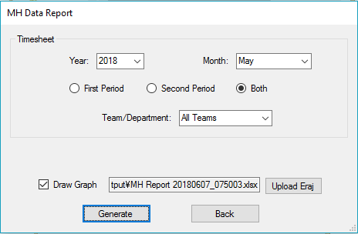

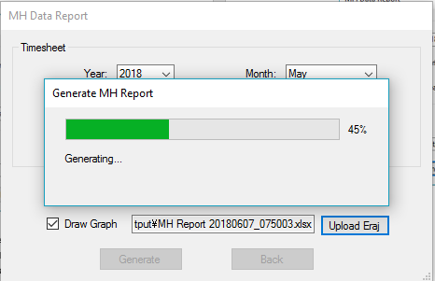

1. A confirmation will appear if generation was successful.

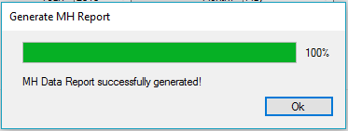

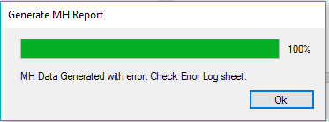A confirmation will also show if there were errors found.

1. To access the generated output, go to the folder that was set on the Output Folder of the Change Settings menu.

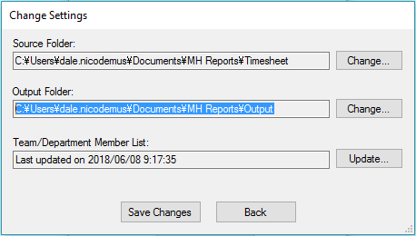

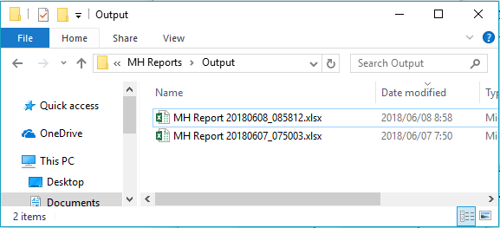

* 1. **Change Settings**

The Change Settings menu allows users to update previously set files, folder directories, as well as FETP Team/Department List. It has three sub menus, Generate Settings, ERAJ Settings, and Exit.

* + 1. **Generate Settings**

The ***Generate Settings*** window is where the file path of the ***Source Folder*** and ***Output Folder*** are changed.

1. Click **Generate Settings** from the menu.

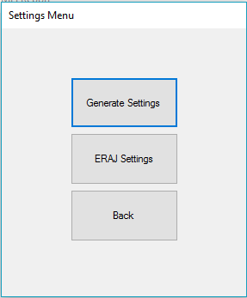

1. Click the ***Change…*** button to change the location of the Source Folder and/or Output Folder.
2. 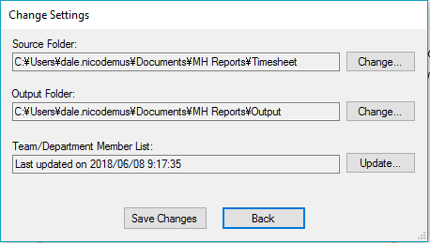Browse for the new location and click ***OK***.

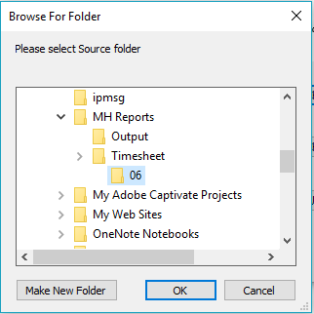

1. If there are updates for the Team/Department List, update the excel first and save. Then click ***Update…***



1. Locate the file for the Team list and click ***Open***.

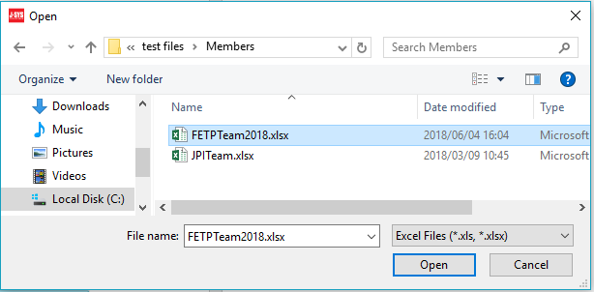

1. Click ***Save Changes***

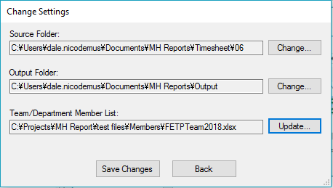.

1. A message will appear if settings were successfully saved. Click ***OK*** to close the window.

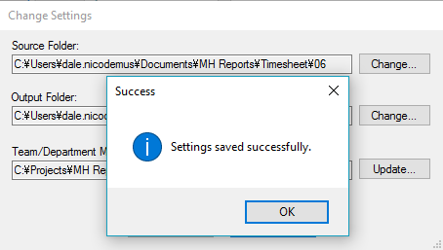

* + 1. **ERAJ Settings**

The ERAJ Settings menu is used to upload the template to be used for drawing the graph. The ***MH Data Report*** and ***Draw Graph*** sub menus will use this setting to generate the ERAJ graph using the given template.

1. Click the ***ERAJ Settings*** button.

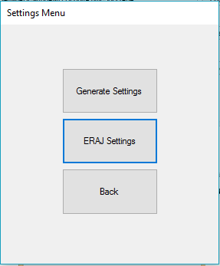

1. Click the ***Browse…*** button

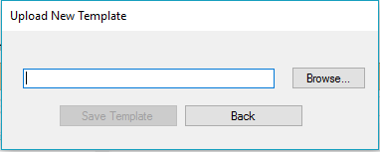

1. Select the ERAJ Template provided and click ***Open***.

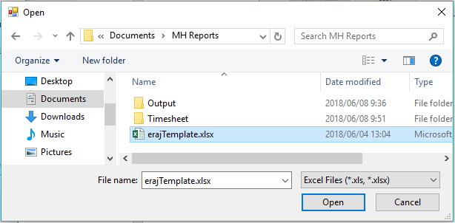

1. Click ***Save Template***.

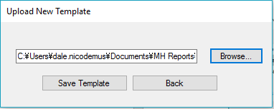

1. A message will appear if settings were saved successfully.
2. 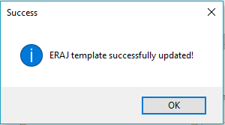Click ***Back*** to return to the main menu.
   1. **Draw Graph**

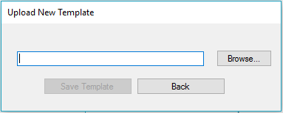Draw Graph is the menu option to graph ERAJ data. Users have the option to use a blank ERAJ template or use a file with the previous month’s graph. A blank ERAJ file will only graph one month, while an ERAJ file with previous records will show the trend from the previous months up to the current month.

1. Click the ***Draw Graph*** button.
2. 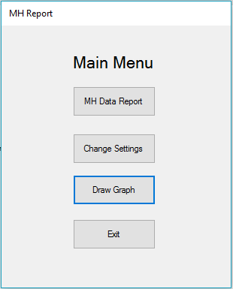In the ***Draw ERAJ*** window, click the Upload button to select the ***Team Totals Source*** and ***ERAJ Template Source***. The Team Totals Source is where the summarized timesheets are saved, and the ERAJ Template Source is the location for the ERAJ Template file.

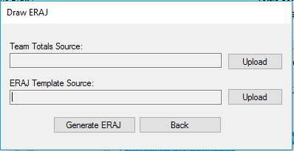

1. Choose the location of the files and click ***Open***.

***Team Totals Source:***

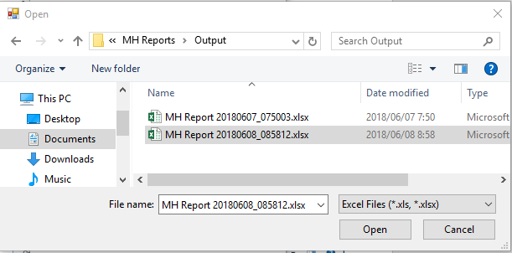

***ERAJ Template Source:***

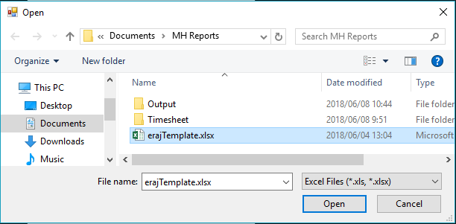

1. Click ***Generate ERAJ***.

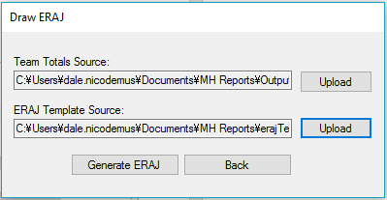

1. A message will appear if ERAJ was successfully generated.

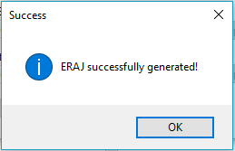

1. Click ***Back*** to go back to Main Menu.

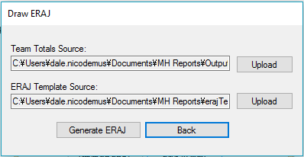

1. **Sample Reports Overview**
   1. MH Report

The MH Report is the report generated from the MH Data Report menu. This summarizes the timesheets for a selected month. The report can be generated for all teams or a specific team. It can also be set to summarize the 1st period, 2nd period or both periods of the timesheet. Below is an overview of the sheets on the MH report.

1. Summary

This is the main sheet of the MH Report and that shows the man hour summary per team, per type of job code, as well as the month’s grand total. The first cell also shows the particular Month of the timesheet.

1. 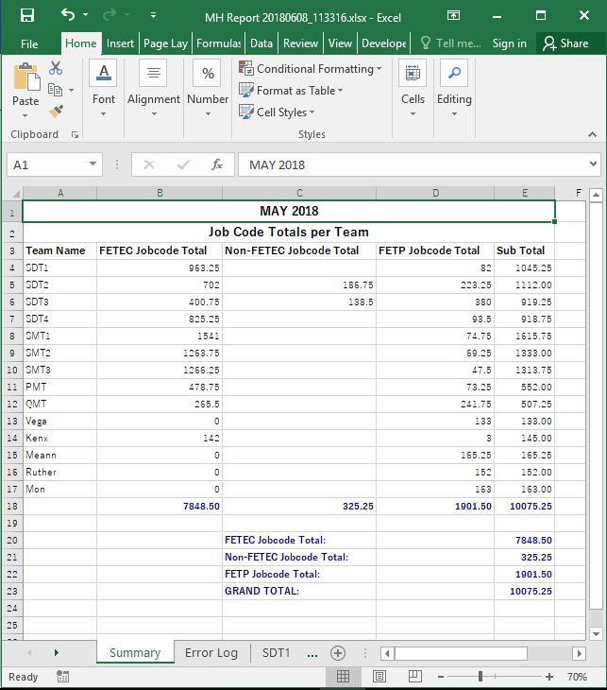Sample of summary for MH Report for all teams.
2. Sample summary for MH Report for a specific team.
3. 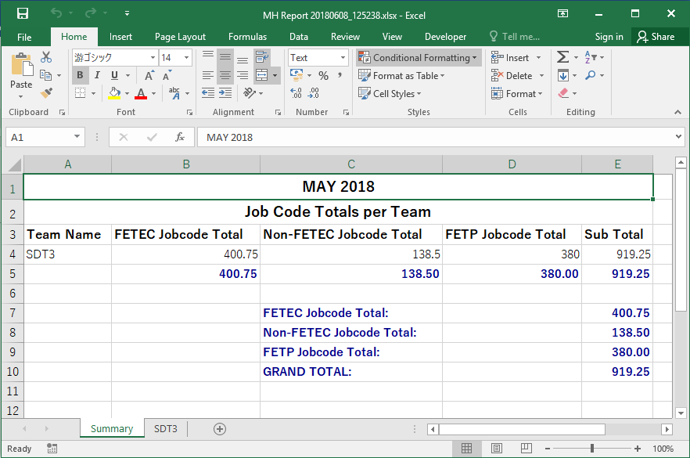Error Log

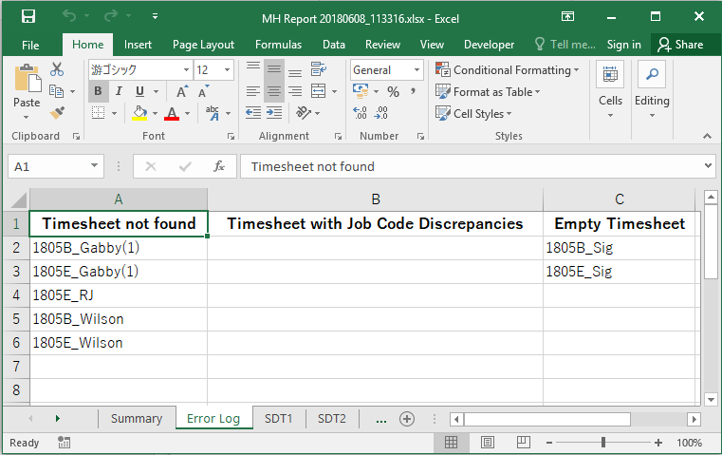If there were any issues on generating the MH report, the error log sheet will be created. This sheet will show the specific timesheet that has issue. Refer to Error basic troubleshooting for added details.

1. FETP ERAJ

If the Draw Graph checkbox was checked, an ERAJ sheet will be created. Based on the MH Report generated, the summarized data will be plotted and a graph will be created for that month.

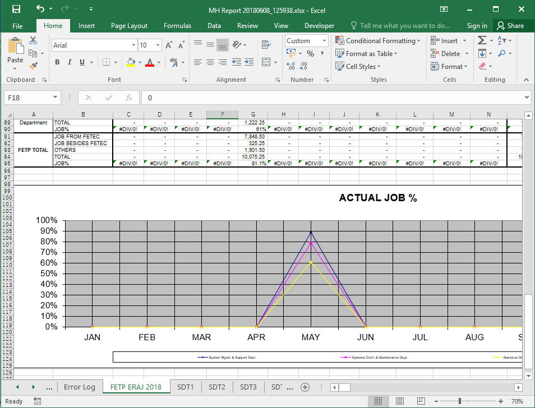

1. Team Names

The next set of sheets will show the summary per team and/or per manager.

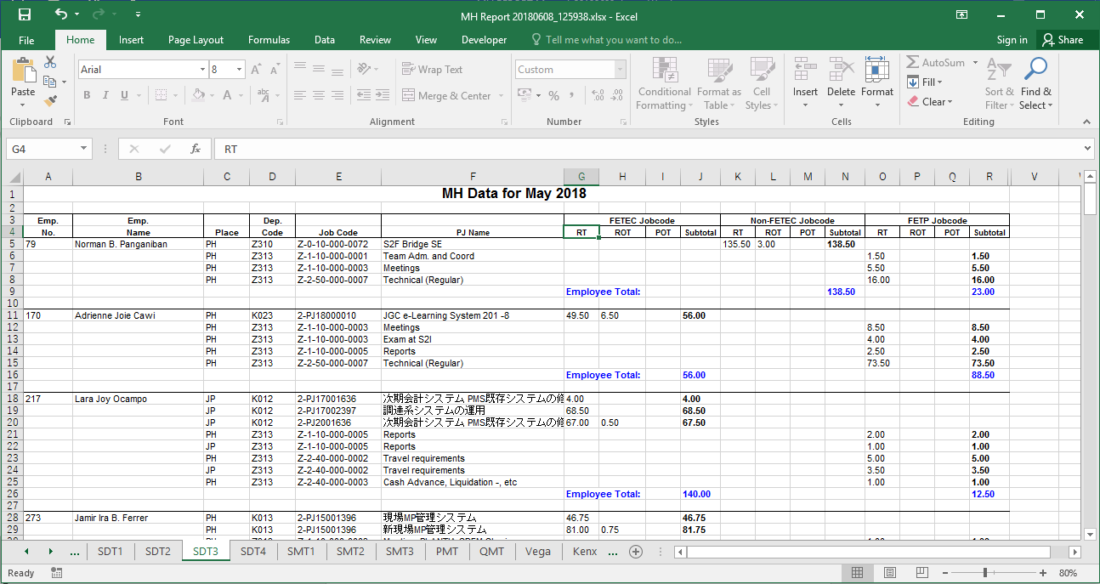

* 1. **ERAJ Graph**

The FETP ERAJ Report is generated from the Draw Graph menu. This would graph the ERAJ for that month. If the ERAJ template file used contains a previous months’ ERAJ, the graph would show the ERAJ trend.

1. ERAJ Sample

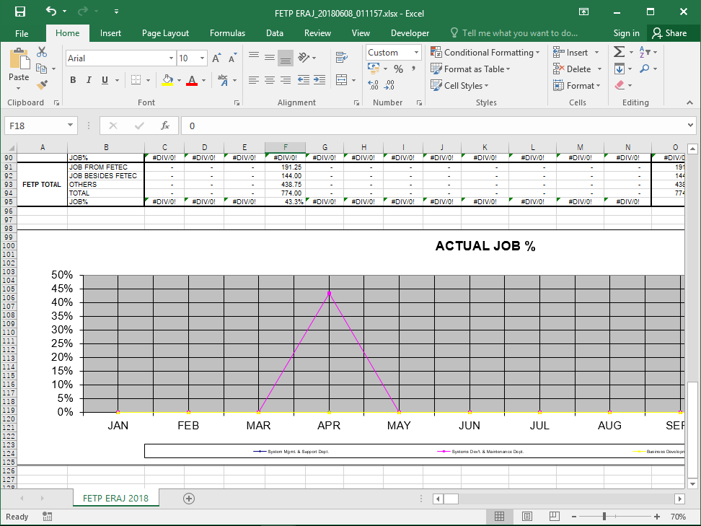

1. ERAJ with previous month’s graph

